R E S O U R C E S

Histogram2D Tools

User Manual

N A T U R A L

Nearshore Habitat Program

Aquatic Resources Division

Washington State Department of Natural Resources

May 2023





Acknowledgements

The Nearshore Habitat Program is part of the Aquatic Resources Division in the Washington Department of Natural Resources (DNR), the steward for state-owned aquatic lands. Program funding is provided through the Aquatic Lands Enhancement Act. The Nearshore Habitat Program monitors and evaluates the status and trends of marine vegetation for DNR in association with the Puget Sound Partnership as one component of the Puget Sound Ecosystem Monitoring Program (PSEMP).

Washington State Department of Natural Resources

Aquatic Resources Division

1111 Washington St. SE

P.O. Box 47027

Olympia, WA 98504-7027

www.dnr.wa.gov

Copies of this report may be obtained from GitHub:

<https://github.com/WA-Nearshore/histogram2Dtools>

Abstract

The Histogram2D Tools consist of four ArcGIS Pro script tools and supporting files. The purpose of these script tools is to enable interactive exploration of the spectral properties of multi-band imagery. It was developed to aid in image classification and the use of spectral rules for isolating a particular class. The tools allow the user to create a 2-dimensional spectral frequency histogram from two specified bands of an image. The user can also delineate polygon areas of interest (AOI) within the image and locate the associated pixels on the histogram. Likewise, polygon AOIs within the histogram can be associated with pixels in the image.

The initial version of the tools (May 2023), publicly available on GitHub[1], is a beta release for testing. There are significant known issues. This User Manual describes each tool and the known issues.

Contents

1. Download and Setup 4

2. Usage 6

3. Import Layout Tool 6

4. Image to Histogram Tool 8

5. Polygon to Histogram Tool 10

6. Polygon to Image Tool 12

7. Known Issues 14

8. Developer Notes 15

# Download and Setup

The repository that contains the four Histogram2D tools, the associated files, and this User Manual, is available on GitHub at

<https://github.com/WA-Nearshore/histogram2Dtools>

The entire repository can be downloaded as a Zip archive by clicking on the “Code” button on the GitHub repository web page. This brings up a menu that includes the “Download ZIP” option (Figure 1‑1).



Figure ‑. Screenshot of the GitHut repository page. The ‘Code’ button is selected to bring up the menu outlined here in red. Then ‘Download ZIP’ is selected to download the repository to a local system.

Once the repository has been downloaded and uncompressed, a total of 14 files are available. These include 5 Python files (grouped in the ‘code’ folder), 4 ArcGIS Pro layer files (.lyrx), and one each of layout (.pagx), projection (.prj), Toolbox (.atbx), README (.md) and this User Manual. The projection, README and User Manual files are not visible from within ArcGIS Pro (Figure 1‑2).

The tools can be run within ArcGIS Pro from a catalog folder connection (Figure 1‑2) or by adding the toolbox to the catalog Toolbox container (Figure 1‑3).



Figure ‑. The contents of the Histogram2D repository as seen in Windows File Explorer (left) and from the Catalog Pane within ArcGIS Pro (right) once a connection to the folder is established. The tools can be run from this folder connection.

 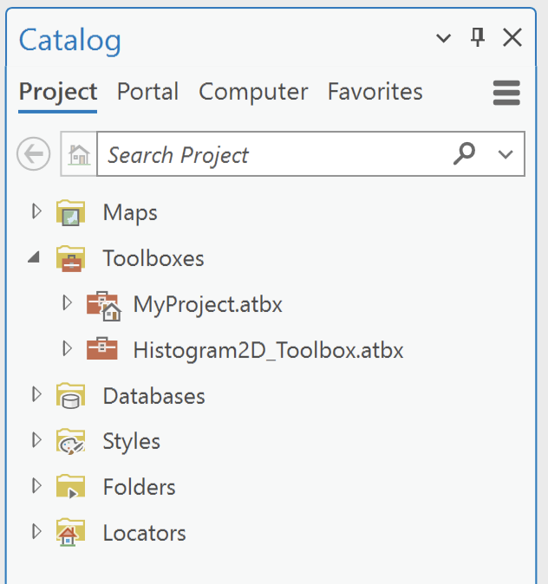

Figure ‑. Optionally, to make the downloaded tools easily accessible within ArcGIS Pro, right-click Toolboxes within the Catalog Pane and select Add Toolbox (left) and then navigate to the location of the downloaded toolbox. The Histogram2D Toolbox is then available from the Catalog Toolboxes container (right).

# Usage

The tools can generally work with any 8-bit multiband imagery format that is supported by ArcGIS Pro. When an image classification workflow involves applying a mask to focus the classification to a subset of the image, the mask should be applied to the image beforehand so that these tools operate on the masked image subset. One way this can be achieved in ArcGIS Pro is with a polygon subset delineation and the Extract by Mask tool (Data Management Tools / Extraction Toolset).

The 2-dimensional histograms created are ArcGIS rasters rather than graphs or plots. They are the same data type as the original image but must be viewed on a special map. The axes do not represent dimensions in geographic space. Rather, the axes are integer row and column dimensions in ‘histogram space’. The row and column of each pixel represent the brightness values (0 – 255) of the two specified bands of the original image. The Import Layout tool creates a map named 'Histogram’ that has a custom ‘Cartesian Row/Column” coordinate system. The presence of this map is required by the other tools.

Generally, when using these tools in a new ArcGIS Pro project, the Import Layout tool will be used first, followed by the Image to Histogram tool. Then the Polygon to Histogram and Polygon to Image tools can be used iteratively while alternately updating visualizations in image space and in histogram space.

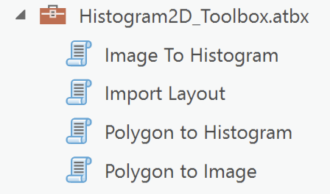

Figure ‑. The four tools.

# Import Layout Tool

## Description

The Import Layout tool imports a layout from the specified layout file into the current ArcGIS Pro project. This tool, or one of the alternatives given below, should be run before the other tools when working in a new project. Specifically, this tool should be run with the layout file *Histogram_layout.pagx* included in the repository. Specification of the layout file is the only parameter of this tool (Figure 3‑1).

When the tool is used with *Histogram_layout.pagx*, a layout named ‘HistogramLayout’ and an associated map named ‘Histogram’ are created in the current project open in ArcGIS Pro (Figure 3‑1).



Figure ‑. The Geoprocessing pane as it appears when the Import Layout tool is run, showing the single required input (left). When the tool is used with the layout file *Histogram_layout.pagx*, a new layout and a new map are created in the current ArcGIS Pro project (right).

The purpose of the layout is to provide a grid and a legend for the histograms which may be preferred for viewing or saving histograms as an image file (e.g., jpg or png). While the layout is not necessary when running the other tools, the ‘Histogram’ map is required.

There are two simple alternatives to using this tool that will also meet the requirements for use of the other tools. The first alternative uses the Import Layout tool available through the ribbon in the ArcGIS Pro interface. The Import Layout tool in the Project group on the Insert tab, brings up a menu (Figure 3‑2). Selecting ‘Import layout file…’ at the bottom of this menu is equivalent to running the Import Layout tool included in the Histogram2D Tools.

The simplest alternative to this tool that meets the requirements of the other tools is to create a new map named ‘Histogram’ in the ArcGIS Pro project, either from the Insert menu or from the Catalog pane. If this map is left empty, then when the Image to Histogram tool is run a layer will be added to the map and the map will take on the Cartesian Row Col coordinate system that is included in the repository as an ArcGIS projection file.

## Requirements

* The ArcGIS Pro layout file (.pagx) included with the repository, *Histogram_layout.pagx,* is required to use as input.

## Input

* Layout File: An ArcGIS Pro layout file (.pagx).

## Output

* A layout named HistogramLayout added to the current ArcGIS Pro project.
* A map named Histogram is added to the current ArcGIS Pro project.



Figure ‑. The Import Layout tool on the ArcGIS Pro ribbon displays the menu outlined here in red. Selecting ‘Import layout file…’ at the bottom of the menu is equivalent to running the Import Layout tool included in the Histogram2D Tools repository.

# Image to Histogram Tool

## Description

This tool generates a 2-dimensional spectral frequency histogram from an 8-bit multiband remote sensing image (Figure 4‑1). The output histogram is an ArcGIS raster dataset of dimension 256x256 pixels with a custom Cartesian Row Col coordinate system. The location of each pixel in the histogram specifies a brightness value pair. The pixel row indicates the 8-bit brightness value in one band (for rows 0-255), and pixel column indicates brightness value in another band (for columns 0-255).

If an image classification workflow applies a mask prior to classification, then it is best to use the masked image as input to this tool, so the histogram created is focused on the area of interest (Figure 4‑1).

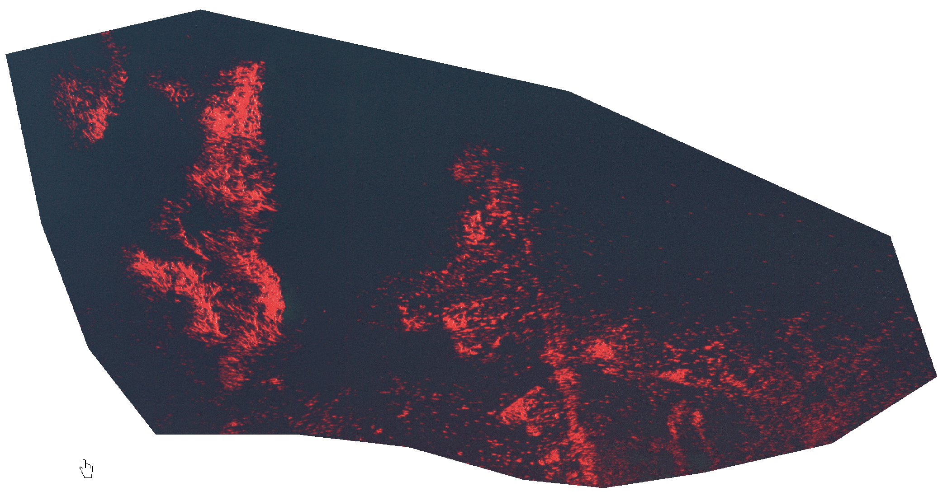

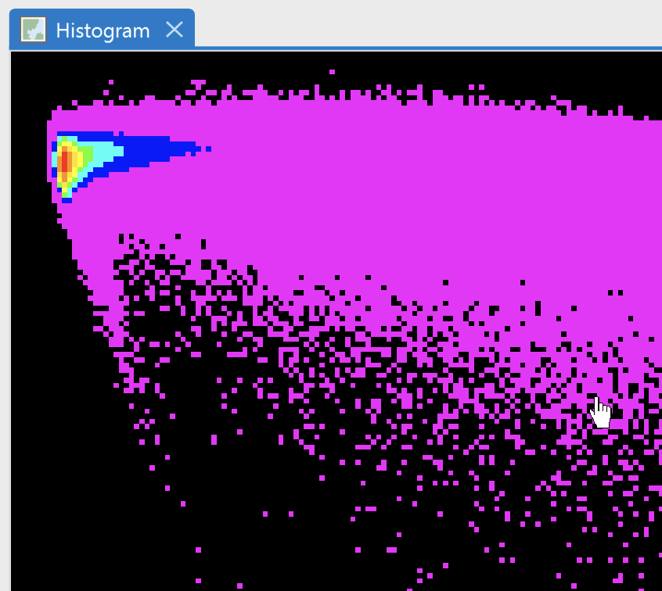

Figure ‑. Examples of input and output for the Image to Histogram tool. On the left, the input is an R-G-B-NearIR shoreline image that has been masked to the area of a kelp bed. On the right, the output is a 2-dimensional frequency histogram. The histogram is a 256x256 raster with pixel column representing the near-IR brightness value [0,255] and pixel row representing the blue brightness value [0,255]. The colors represent the pixel frequency in the input image for each brightness value pair. The output histogram raster uses a custom Cartesian Row Col coordinate system.

## Requirements

* A map named Histogram must be present in the current ArcGIS Pro project.

## Input

* Geographic Input Image: the 8-bit multiband image from which the 2-dimensional histogram is to be made.
* Histogram Symbology: an ArcGIS Pro layer file (.lyrx) that provides raster symbology for the histogram. Two layer files are provided in the repository:
  + hist_symbology.lyrx: a classified symbology with fixed bins. This is appropriate when the same bins are needed across a series of histograms.
  + hist_symbology_nbj.lyrx: a classified symbology with dynamic bins based on Natural Breaks (Jenks).
* x-Axis Band: the band number within the image to be used for the x-axis (columns) of the histogram. Band numbering starts from 1. The default value is 4.
* y-Axis Band: the band number within the image to be used for the y-axis (rows) of the histogram. Band numbering starts from 1. The default value is 3.

## Output

* Raster dataset: The 2-dimensional histogram created is saved as a raster dataset to the same geodatabase containing the source remote sensing image. The saved raster dataset has the same name as the input image but with a “_hist” suffix.
* Raster layer: The 2-dimensional histogram created is added to the Histogram map within the current ArcGIS Pro project with symbology specified by the input layer file.

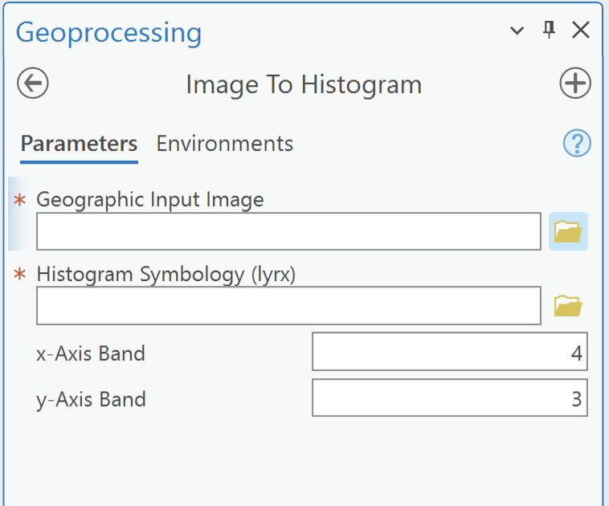

Figure ‑. The Geoprocessing pane that appears when the Image To Histogram tool is opened, showing the required inputs or this tool.

# Polygon to Histogram Tool

## Description

This tool generates a 2-dimensional spectral frequency histogram from the pixels within a remote sensing image AOI (area of interest) defined by a polygon. The histogram generated is based on the two image bands specified as input parameters and has a custom Cartesian Row Col coordinate system.

The polygon can be in a map layer, in a feature class within a file geodatabase, or it can be created on-the-fly from the tool interface using the interactive feature input button (Figure 5‑1). If the polygon data source has multiple polygons, all are included in the AOI except in the case of a map layer with an active selection in which case the selected polygon(s) define the AOI.



Figure ‑. The Geoprocessing pane that appears when the Polygon to Histogram tool is opened, showing the required inputs for this tool.

In a typical workflow, a histogram of the input image would have been previously generated with the Image to Histogram tool. In this case, the AOI-based histogram can be used as a mask when overlaid on the histogram representing the entire input image (Figure 5‑2). A layer file *mask_symbology.lyrx* included in the repository can be used to provide a simple symbology for this purpose, but this symbology must be applied manually.

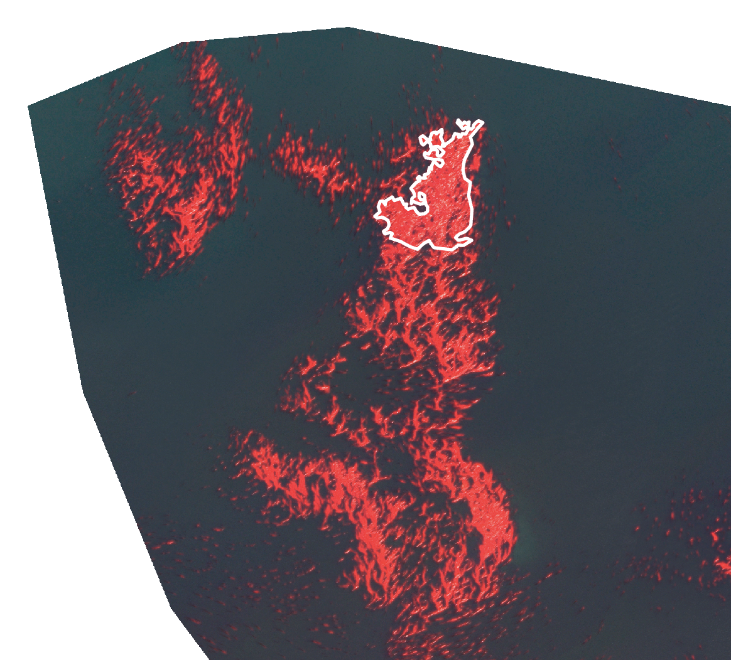 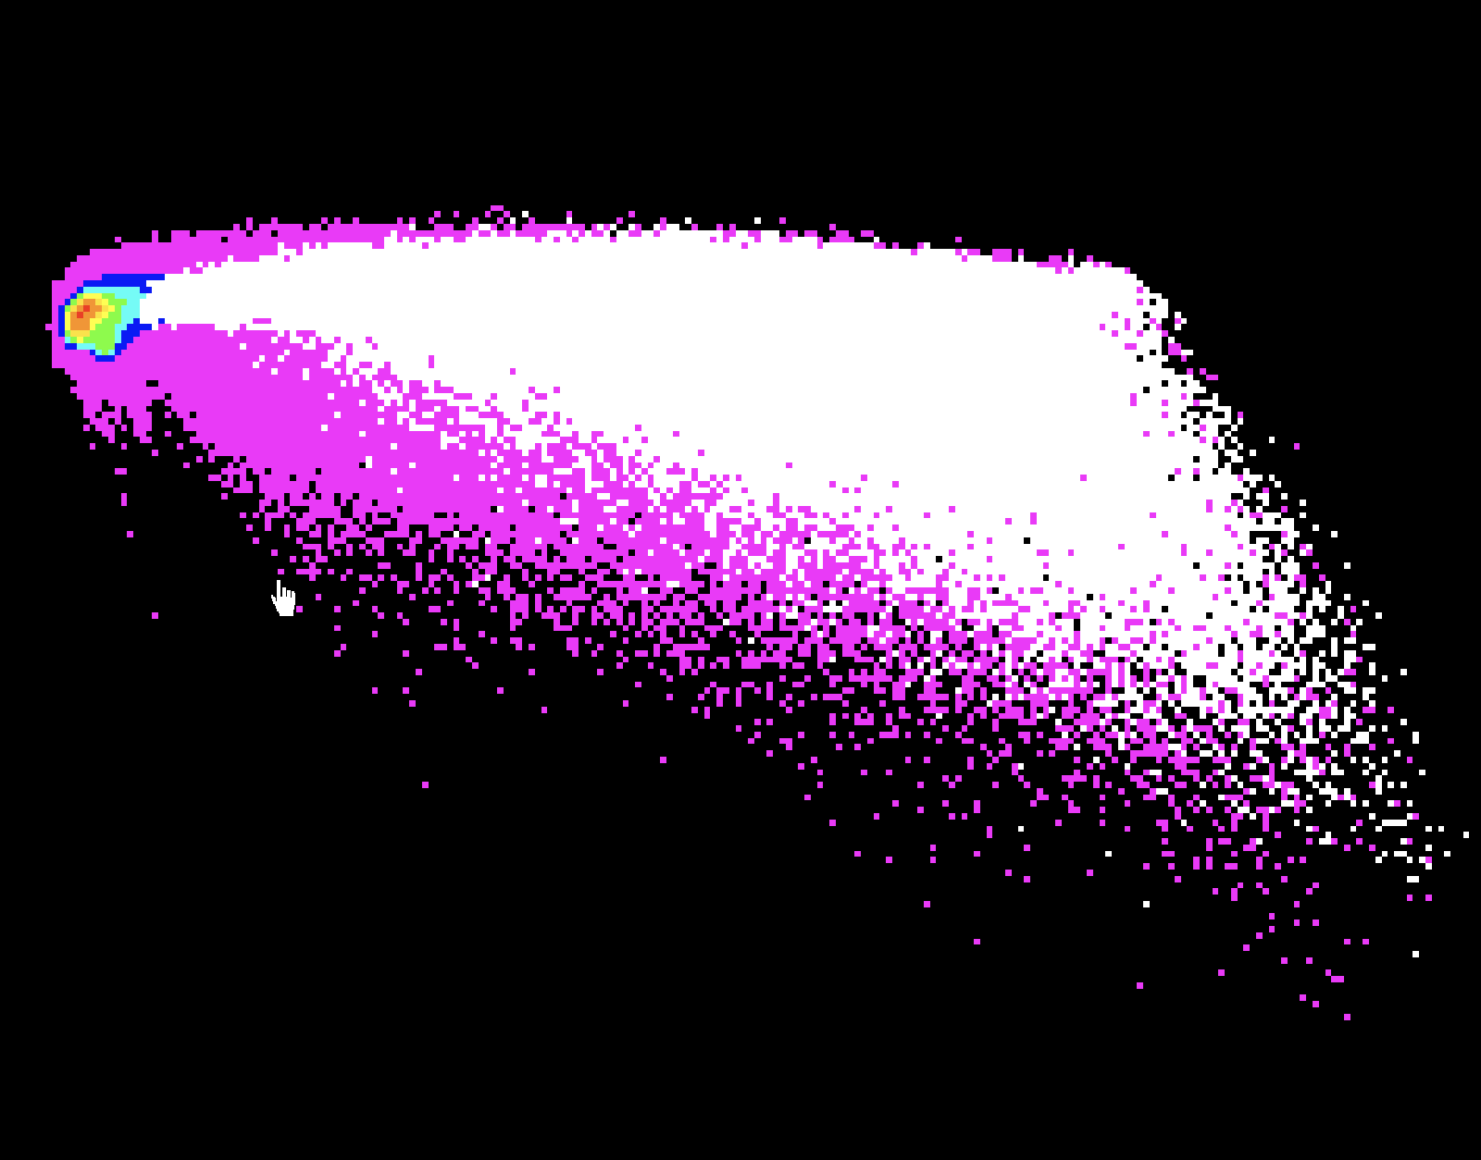

Figure ‑. Examples of input and output for the Polygon to Histogram tool. On the left, the input includes both the source geographic image and a polygon to define an AOI. On the right, the output is a 2-dimensional histogram based generated from image pixels within the polygon AOI. This output histogram is presented here as white pixels overlain over the histogram for the entire input image.

The histogram generated by this tool is saved as a raster dataset to the same geodatabase containing the source remote sensing image. To view the histogram, it must be added to a map.

## Requirements

* A map named Histogram must be present in the current ArcGIS Pro project.
* A histogram must have been previously created with the Image to Histogram tool.

## Input

* Geographic Input Image: the 8-bit multiband image from which a polygon AOI is used to generate the 2-dimensional histogram.
* Polygon AOI: a polygon layer containing the polygon(s) that define the AOI to be used to generate the histogram. This input can be a layer within the active map within ArcGIS Pro, a feature class, or a polygon made interactively.
* x-Axis Band: the band number within the image to be used for the x-axis (columns) of the histogram. Band numbering starts from 1. The default value is 4.
* y-Axis Band: the band number within the image to be used for the y-axis (rows) of the histogram. Band numbering starts from 1. The default value is 3.

## Output

* Raster dataset: The 2-dimensional histogram created is saved as a raster dataset to the same geodatabase containing the source remote sensing image. The saved raster dataset has the same name as the input image but with a “_AOI2hist” suffix.
* Raster layer: The 2-dimensional histogram created is added to the Histogram map within the current ArcGIS Pro project with symbology specified by the input layer file.

# Polygon to Image Tool

## Description

This tool generates a mask that matches the geographic coordinate system and extent of the source remote sensing image. The mask identifies pixels within the source image that have spectral properties that match a polygon AOI specified within the histogram associated with the image. Specifically, the mask identifies image pixels with brightness values in the two specified bands that match the cells within the polygon AOI of the histogram associated with that source image (Figure 6‑1).

The polygon AOI can be in a map layer, in a feature class within a file geodatabase, or it can be created on-the-fly from the tool interface using the interactive feature input button (Figure 6‑2). If the polygon data source has multiple polygons, all are included in the AOI except in the case of a map layer with an active selection in which case the selected polygon(s) define the AOI.

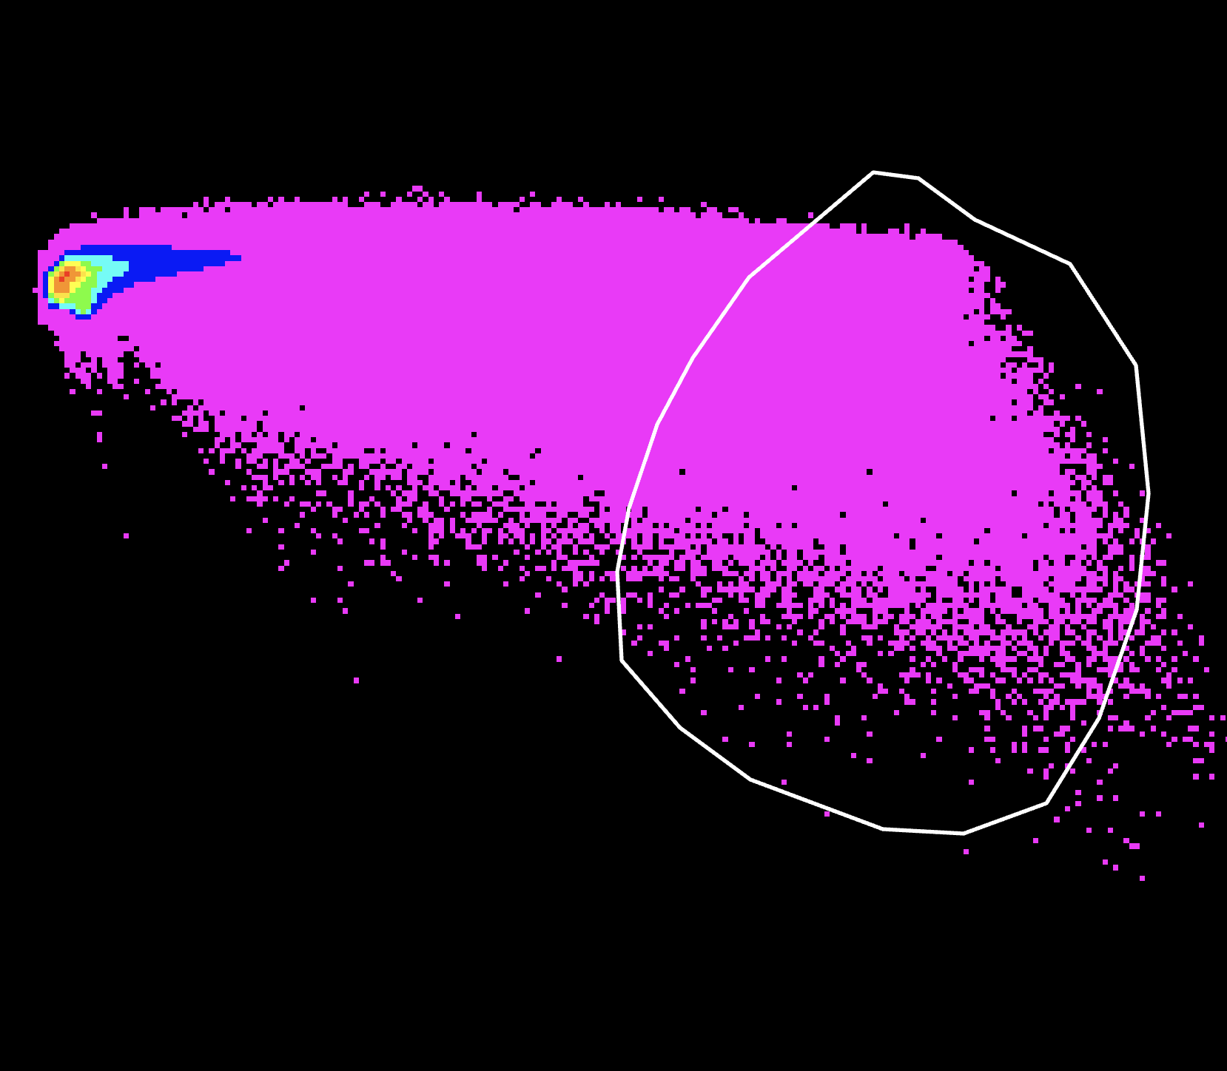 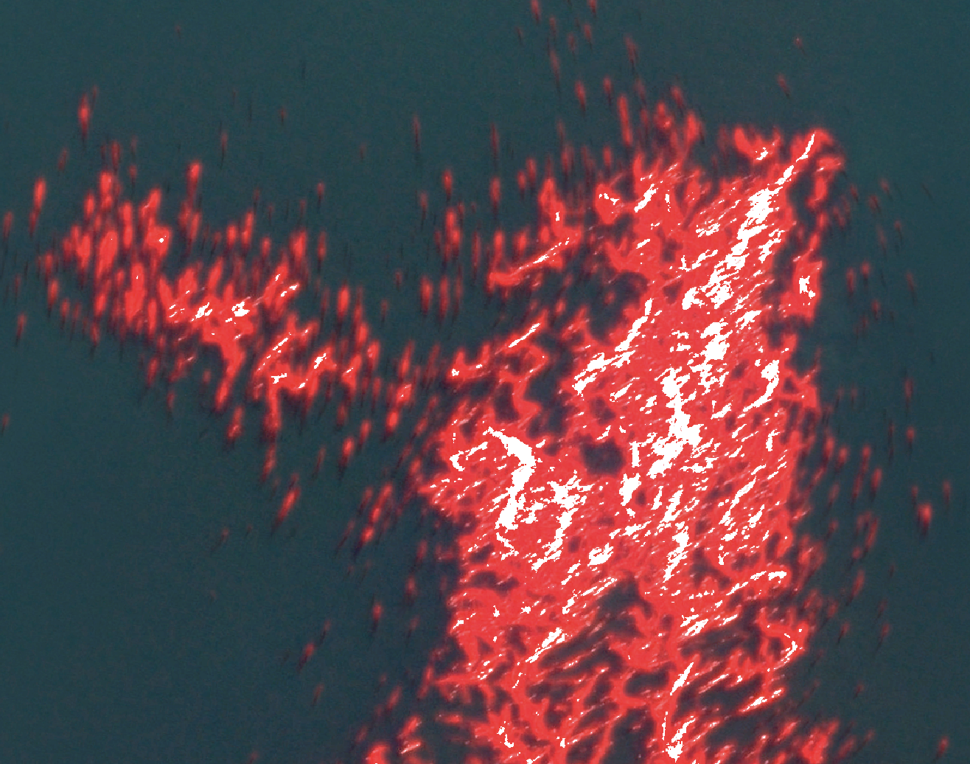

Figure ‑. Examples of input and output for the Polygon to Image tool. On the left, the input includes both a histogram and a polygon to define an AOI within the histogram. On the right, the output is a mask, shown here in white, indicating the image pixels with spectral characteristics that match the histogram AOI.

## Requirements

* A map named Histogram must be present in the current ArcGIS Pro project.
* A histogram must have been previously created with the Image to Histogram tool.

## Input

* Histogram: the previously created histogram generated from the remote sensing image specified in the Geographic Image input field. This histogram can be specified as a layer if the active map within ArcGIS Pro is the Histogram map. It can also be specified as a raster dataset, e.g. within a file geodatabase.
* polyAOI: a polygon layer containing the polygon(s) that defines the AOI within the histogram. This AOI will be used to generate the image mask. This input can be a layer if the Histogram map is active within ArcGIS Pro, a feature class, or a polygon made interactively (Figure 6‑2).
* Geographic Input Image: the 8-bit multiband image that was used to generate the histogram specified in the Histogram field.
* x-Axis Band: the band number within the image that was used for the x-axis (columns) of the histogram. Band numbering starts from 1. The default value is 4.
* y-Axis Band: the band number within the image that was used for the y-axis (rows) of the histogram. Band numbering starts from 1. The default value is 3.

## Output

* Raster dataset: The remote sensing image mask created is saved as a raster dataset to the same geodatabase containing the remote sensing image. The saved raster dataset has the same name as the input image but with a “_hist_AOI2img” suffix. This raster dataset must be manually added to a map for viewing.



Figure ‑. The Geoprocessing pane that appears when the Polygon to Image tool is opened, showing the required inputs for this tool.

# Known Issues

## Symbology problem on first usage

The Image to Histogram tool does not successfully apply symbology to the created histogram when first used within an ArcGIS Pro project (Figure 7‑1). When this happens, the simplest solution is to manually apply symbology using the following steps:

1. Open the Symbology pane by right-clicking on the histogram layer in the Histogram map, and select Symbology.
2. On the Symbology pane, open the menu at the upper right of the pane and select ‘Import from layer file’ and then navigate to one of the histogram layer files included in the respository – either *hist_symbology.lyrx* for a static symbology, or *hist_symbology_nbj.lyrx* for a dynamic symbolgy.

Alternatively, the Image to Histogram can just be run a second time to produce a histogram that is correctly symbolized. In limited testing, subsequent uses of the tool ran successfully.

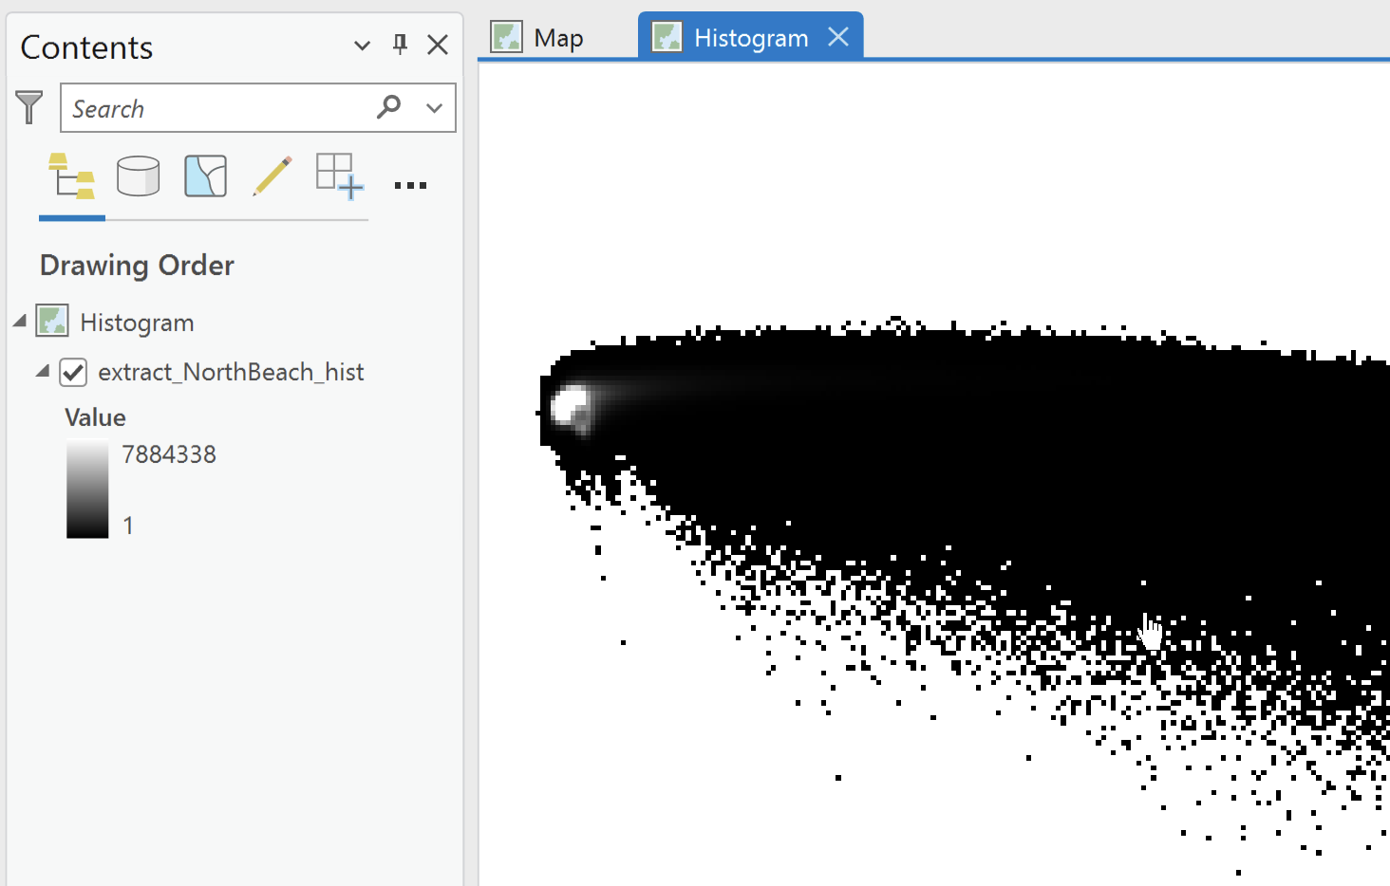

Figure ‑. Example of a histogram output from the Image to Histogram tool, where specification of the color symbology has failed.

## Limited to 8-bit imagery

The tools are currently limited to 8-bit imagery such that pixel brightness values in each image band range from 0 to 255 (for n=256 values). The tools would have unpredictable behavior if run with 16-bit imagery (brightness value range: 0 to 65535) and any output produced would be unreliable.

## Reuse problem with interactive AOI creation

In testing with interactive AOI creation (Polygon to Histogram and Polygon to Image tools), it was found that the polygon layer created was automatically save to the default geodatabase for the ArcGIS Pro project.

A problem occurs when the saved polygon layer is used to specify the AOI on subsequent uses of the tool. The tool does not successfully produce output and an error message indicates that the extent of the polygon layer is not valid. This can be corrected by using the Recalculate Feature Class Extent tool (Data Management Tools, Feature Class toolset).

## No layer tracking

The tools have no layer tracking capability. It is incumbent on the user to track which image bands have been used to create any particular histogram. Similarly, the user must track output using different AOIs, and track the correspondence between a histogram and the associated source image.

# Developer Notes

## Symbology bug

The symbology bug prevents the successful application of symbology to a histogram created by the Image to Histogram tool. This bug is tied to the use of the Arcpy function ApplySymbologyFromLayer() in the Python script *i2h_tool.py*. Web searches revealed that issues with this function are common. There was at least one bug with this function acknowledged by Esri, but that has since been classified as resolved.

The use of the function was wrapped in a try-except block to intercept the failure and respond appropriately. This was unsuccessful - when the function does not successfully apply symbology, no error is thrown and the except block is not executed. This suggests that this Arcpy function still has a bug that is causing this behavior.

A resolution to this problem could be pursued through a bug report process with Esri, or by implementing some temporary workaround. Since the failure only occurs on the first usage of the tool within an ArcGIS Pro project, one possible workaround would be to automatically invoke the ApplySymbologyFromLayer() function for some dummy layer.

## Expanding to 16bit

If the scope of these tools was expanded to accommodate 16-bit imagery, the main concern would be hitting memory limitations or performance issues.

Currently, the 8-bit code creates an intermediate raster layer with 32-bit values that has dimensions dictated by the image bit depth. For 8-bit imagery, this intermediate raster layer is 256 x 256 pixels with 32-bit values. If the same code were adapted to 16-bit data, this intermediate layers would have dimensions 65536 x 65536 with 32-bit values. The footprint of that layers would be 128 GB. With a layer of this size, performance issues may be expected.

1. https://github.com/WA-Nearshore/histogram2Dtools